**Types of Acceptance Testing**

**Types**

There are several types of this testing.

**A few of them are listed below:**

#1) User Acceptance Testing (UAT)

UAT is to assess whether the Product is working for the user, correctly for the usage. Specific requirements which are quite often used by the end-users are primarily picked for the testing purpose. This is also termed as End-User Testing.The term “User” here signifies the end-users to whom the Product/application is intended and hence, testing is performed from the end-users perspective and from their point of view.

#2) Business Acceptance Testing (BAT)

This is to assess whether the Product meets the business goals and purposes or not. BAT mainly focuses on business benefits (finances) which are quite challenging due to the changing market conditions/advancing technologies so the current implementation may have to undergo changes that result in extra budgets. Even the Product passing the technical requirements may fail BAT due to these reasons.

#3) Contract Acceptance Testing (CAT)

This is a contract that specifies that once the Product goes live, within a predetermined period, the acceptance test must be performed and it should pass all the acceptance use cases. Contract signed here is termed a Service Level Agreement (SLA), which includes the terms where the payment will be made only if the Product services are in-line with all the requirements, which means the contract is fulfilled. Sometimes, this contract may happen before the Product goes live. Either way, a contract should be well defined in terms of the period of testing, areas of testing, conditions on issues encountered at later stages, payments, etc.

#4) Regulations/Compliance Acceptance Testing (RAT)

This is to assess whether the Product violates the rules and regulations that are defined by the government of the country where it is being released. This may be unintentional but will impact negatively on the business. Usually, the developed Product/application that is intended to be released all over the world, has to undergo RAT, as different countries/regions have different rules and regulations defined by their governing bodies. If any of the rules and regulations are violated for any country, then that country or the specific region in that country will not be allowed to use the Product and is considered a Failure. Vendors of the Product will be directly responsible if the Product is released even though there is a violation.

#5) Operational Acceptance Testing (OAT)

This is to assess the operational readiness of the Product and is non-functional testing. It mainly includes testing of recovery, compatibility, maintainability, technical support availability, reliability, fail-over, localization, etc. OAT mainly assures the stability of the product before releasing it to production.

#6) Alpha Testing

This is to assess the Product in the development/testing environment by a specialized testers team usually called alpha testers. Here, the tester’s feedback, and suggestions help to improve the Product usage and also to fix certain bugs. Here, testing happens in a controlled manner.

#7) Beta Testing/Field Testing

This is to assess the Product by exposing it to the real end-users, usually called beta testers/beta users, in their environment. Continuous feedback from the users is collected and the issues are fixed. Also, this helps in enhancing/improving the Product to give a rich user experience. Testing happens in an uncontrolled manner, which means a user has no restrictions on the way in which the Product is being used.

[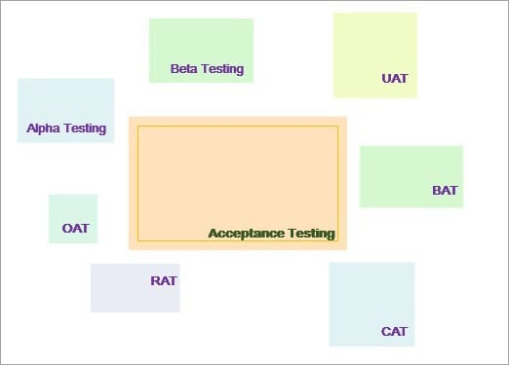](https://www.softwaretestinghelp.com/wp-content/qa/uploads/2018/01/Types-of-Acceptance-Testing.jpg)

**All these types have a common goal:**

* *Ensure to gain/enrich Confidence in the Product.*
* *Ensure that the Product is ready to be used by real users.*